Today you will have a lesson at the State Museum of the Defence of Moscow. You will have to complete different tasks to guess a secret word at the end of the lesson. For unfamiliar words you may consult the active vocabulary list on the last page of your worksheet.
The State Museum of the Defence of Moscow was founded on December 25, 1979. The Museum shows different wartime periods and subjects, focusing on the first ten months of the war, tells the visitors about fighting against enemy aviation, life near the front line and counteroffensive.
Lead-in
Study the text about the Battle of Moscow. Read the sentences below the text and point out if the information is true (T), false (F) or not stated (NS).
The Battle of Moscow was a military campaign that consisted of two periods: defence (30 September 1941 – 5 December 1941) and counteroffensive (5 December 1941 – 20 April 1942). The Soviet troops stopped Hitler's attack on Moscow, the capital and largest city of the Soviet Union. Moscow was one of the primary military and political objectives for Nazi Germany in the invasion of the Soviet Union.
- The campaign consisted of three periods.
- The counteroffensive lasted 7 months.
- The capital of the Soviet Union was St Petersburg.
- Moscow was the largest city of the Soviet Union.
- More than 2 million people escaped from Moscow.
a) | b) | c) | d) | e)
F | F | F | T | NS

Take the fourth letter from the name of the capital of the Soviet Union to guess the secret word at the end of the lesson. It’s going to be the third letter of the secret word.
³C

Task 1. Study the map of the defensive positions of Moscow. How many defensive lines were there around Moscow? Count only the main defensive lines, which were very close to the centre of Moscow.
There were three defensive lines.
Take the third letter from the numeral, which is the number of the main defensive lines of Moscow to guess the secret word at the end of the lesson. It’s going to be the sixth letter of the secret word.

⁶R

Task 2. Look at the barricade to the left of the map of the defensive lines. Read the text about the defence of Moscow and do the tasks below it.
The Soviet troops built defensive positions using the most substantial buildings. The defensive lines were built along the streets. The soldiers closed the exits from these streets by barricades and fire means.
Write the following sentences from the text in Passive Voice using the Passive form of the verbs written in capitalized letters.
The most substantial buildings were used by the Soviet troops to build defensive positions.
Defensive positions were built along the streets.
The streets were blocked with barricades and anti-tank obstacles.
What item did soldiers use to build barriers against tanks? Find this item at the exposition of the street. Find out and write down the name of this item (use the pictures and the active vocabulary if you need).

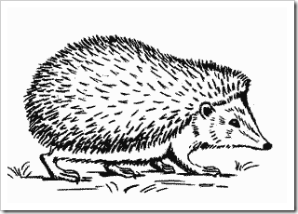

Сzech hedgehog
Task 3. Read the text about a very famous anti-tank barrier. Fill in the gaps with the correct forms of the words written in capitalized letters.
The Сzech hedgehog IS (TO BE) a trap made of three metal BARS (A BAR) bound together. The Soviet Union USED (TO USE) Czech hedgehogs in World War 2 in anti-tank defence. Soldiers BUILT (TO BUILD) Czech hedgehogs at the places where enemy TANKS (A TANK) could appear. THESE (THIS) barriers slowed down the tanks.

Task 4. There is a picture of Moscow street of that time. Look at this picture and describe it using the keywords.
Firewood, tram, pedestrians, houses, wide street, traffic.
You can see a wide street with large houses. A few pedestrians are walking along the street. There isn’t much traffic in the street, we can see only a tram, a bus and a truck. There is a lot of firewood lying along the street.

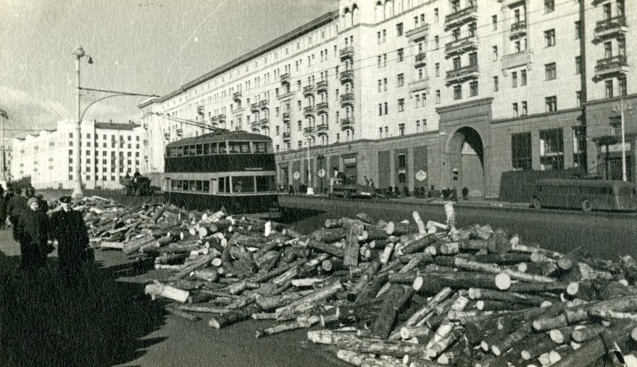
How will this street change after the war? Write a few sentences in Future Simple.
There will be more cars and people in the street. There won’t be any firewood lying along the street.

Task 5. Find the model of the Soviet warfare snowmobile at the exposition of the factory. Who was the engineer of the snowmobile?
I.N. Juvenaliev

Task 6. Match the names of these medals with their pictures. You can find these medals at the exposition of the factory.
- Medal for “Valiant labour in the Great Patriotic War 1941–1945” | 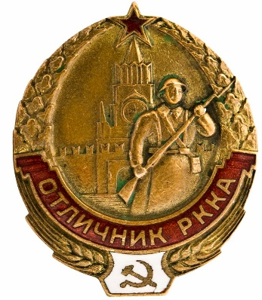
- Excellent worker of the Red Army Research Institute badge | 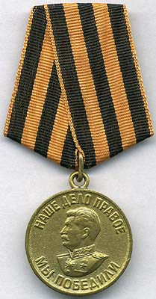
- Medal for “The victory over Germany in the Great Patriotic War 1941–1945” | 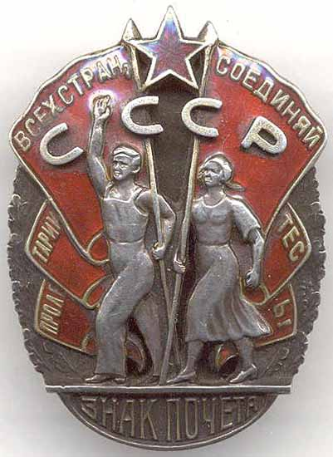
- Order of badge of honour | 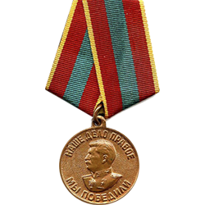

1) | 2) | 3) | 4)
b) | c) | d) | a)

Whom did these medals belong to? What was the profession of this person?
These medals belonged to S.V. Khludov. He was a chemist.
Take the first letter from the name of the medal number four to guess the secret word at the end of the lesson. It’s going to be the first letter of the secret word.
¹V

Task 7. There is an exposition of the Muscovite’s flat. Match the description of the objects with their names. Find these objects in the flat.
- sewing machine | 1) a piece of cloth, that hangs across a window
- wood stove | 2) a picture produced using a camera
- radio | 3)a large container for liquids that usually has a handle
- cupboard | 4) a piece of electronic equipment used for listening to radio broadcasts
- jug | 5) a metal container with a pipe for smoke and a door, and sometimes a place on top to cook on, in which you can burn wood for heat
- curtain | 6) we use this machine for joining together pieces of cloth
- photo | 7) a piece of furniture with a door or doors behind which there is space for storing things, usually on shelves

a) | b) | c) | d) | e) | f) | g)
6) | 5) | 4) | 7) | 3) | 1) | 2)

Take the sixth letter from the name of the object number one to guess the secret word at the end of the lesson. It’s going to be the second letter of the secret word.
²I

Task 8. Find the following objects, which you can see in the pictures at the exposition of the Muscovite’s flat. Name these objects. Match the pictures of these objects with their names.
- postcard;
- Christmas decoration;
- money.
1) 2) 3)
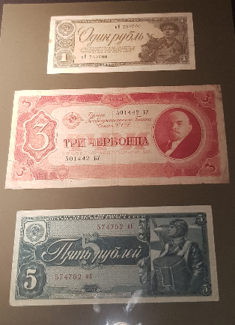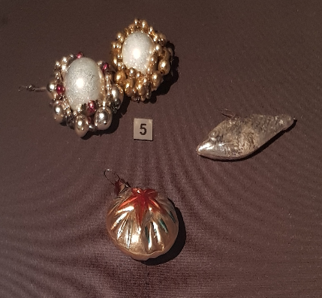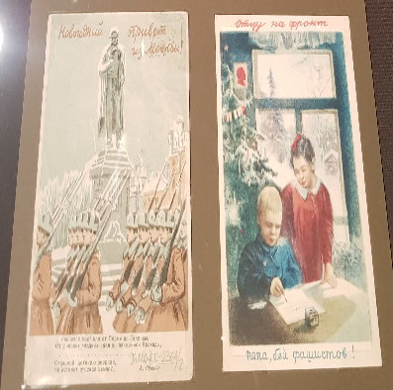

1 | 2 | 3
c) | b) | a)

Which of these objects is uncountable?
money
Take the second letter from the uncountable noun to guess the secret word at the end of the lesson. It’s going to be the fifth letter of the secret word.
⁵O

Task 9. There is a picture at the exposition of a metro station. Look at this picture and answer the questions:
Whom can you see in the picture?
We can see men, women and children.

Where are these people?
They are at the metro station.
How do we call the citizens of Moscow? Take the eighth letter from this word to guess the secret word at the end of the lesson. It’s going to be the fourth letter of the secret word.
⁴T

Task 10. Read the text and answer the questions.
One of the purposes of Moscow Anti-Aircraft Defence was sheltering people from enemy air raids. Three hundred and fifty thousand Muscovites could take refuge in metro stations. You can see the picture of Mayakovskaya station. It served as a shelter. Metro trains stopped running from 8 pm until 5.30 am. Women and children were located in stations and carriages, and men in tunnels.
- What is this text about?
This text is about the usage of the Moscow metro stations as Anti-Aircraft Defence shelters.

- How many Muscovites could take refuge in Moscow metro?
Three hundred and fifty thousand Muscovites could take refuge in Moscow metro.

- What station is in the picture? Did it serve as a shelter?
Mayakovskaya station. Yes, it did.

Take the third letter from the name of the metro station, which served as a shelter to guess the secret word at the end of the lesson. It’s going to be the seventh letter of the secret word.
⁷Y

Task 11. Now the time has come to guess the secret word. Look through the papers once again and fill in the missing letters.
V | I | C | T | O | R | Y

Test
Fill in the gaps using the words from the list. For unfamiliar words you may consult the active vocabulary list.
Typhoon, Soviet, River, began, south, East, took.
On 22 June 1941, Nazi forces invaded the Soviet Union, destroyed most of the Soviet Air Force on the ground, and advanced deep into the country. The German Army Group North moved towards Leningrad, Army Group South took control of Ukraine, and Army Group Centre advanced towards Moscow. By July 1941, Army Group Centre crossed the Dnieper River, on the path to Moscow.
The German strategic offensive named Operation Typhoon was planned to attack Moscow from the north and south. The Soviets reacted by sending in more reserve from the Far East. Shortly, German attacks were stopped, and the Soviets began counter-attack and forced to push the Nazi forces back.

Case
There were three lines and twenty-eight stations in 1945. Zavod Imeni Stalina, Comintern, Stalinskaya, Dvorets Sovetov, Sverdlova, Dzerzhinskaya were renamed.
There are fifteen lines and two hundred and sixty-one stations nowadays.

Active vocabulary
to advance (v) – продвигаться
air raid – воздушный налет
bar (n) – брусок
carriage (n) – вагон
cloth (n) – ткань
counteroffensive (n) – контрнаступление
Czech hedgehog – противотанковый еж
fire means – огневые средства
invasion (n) – вторжение
Nazi forces – нацистские войска
Nazi Germany – нацистская Германия
offensive (n) – наступление
purpose (n) – цель
to take refuge (v) – найти убежище
to serve (v) – служить
to shelter (v) – укрываться
showpiece (n) – экспонат
substantial (adj) – прочный

